Name ___________________________________

The History of the Internet
Student Notes

Part I
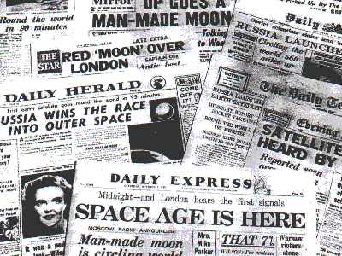
- In ___________ Russia launched the 1st __________________ into space. It was called ___________________.

- Sputnik was a very big ______________________ to the U.S. It left us in shock!

- President ______________ __________________________ responded to Sputnik by doing 3 things:

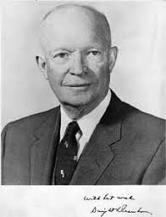
  - He changed ________________ curriculums to emphasize ___________ and _______________.
  - He ordered that the U.S. Department of _______________ be more ____________________ and _____________________ based. In 1958 A_________________ R________________ P_________________ A_____________ (________) was created to meet these goals.
  - NASA was created to win the “__________________ Race” against the Soviets.

- In _______, ___________ ______________________ __________________ ___________________ created a __________________________________, early-warning _____________________ to guard against Soviet nuclear ______________ attack. This _______________ was named _________________. In _____________, it was released to the public and renamed _________________.

- So, who created the Internet? The ___ ____ __________________________. And it was first named _________________.

Part II


- What is the Internet? It is the ___________________ computer network in the world connecting _______________ of ___________________.

- Who is in charge of the Internet? ____________


- WWW stands for _________ _________ _________ and is the most common ____________ we use to access the ____________________. It is a _________ of the Internet and the most __________ part of the ________________.

- What 3 things do you need to get on the Internet:

- ISP stands for _______________ _________________ ____________________ and is a company that connects you to the internet for a monthly fee. Examples are: Comcast, Verizon, AT&T and Earthlink

- Internet Browser is a _______________ ________________ that lets you view ________ documents. Examples are: Internet Explorer, Safari and Mozilla Firefox.

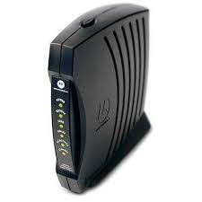
- A modem is a _____________ that allows computers to _________________ to _____________ ____________________ and to send ________________ to each other. Types of modems include: (1) __________________
((2) _______________________ (3) _____________________
((4) _______________________ (5) ________________________
(6) ___________________________

- A URL is also known as a _________ _________________. URL stands for _____________ _____________________ _______________________.

- How to Read a URL:

http://www.apple.com

10. Common Domain Extensions: What they can they you . . .

.com = Country Extensions:
.gov = .uk =
.edu = .ca =
.info = .fr =
.org = .us =
.net = .bz =
.biz =
.tv =
.mil =
.co =
.mobi =
.sch =
.k12 =
.ac =

- A search engine is a program that searches documents on the _______ for __________________.

- Hyperlinks take you to ______________ ___________________ when clicked on.


- Emailing is _________________ and _____________________ messages over the Internet.

- Blog is short for _______ __________ and is a personal _______________ published on the ________.

- Downloading is ________________________ files from _______________ computer to your ____________.

- Uploading is ________________________ files from your _________________ to a web __________________.

- Cookies are ____________ containing ___________________ information about a user. These cookies are ___________________________ sent to the requesting computer anytime it ______________ them. _________________ cookies often!



